|  |  |  |  |  |  |
| --- | --- | --- | --- | --- | --- |
| |  |  |  | | --- | --- | --- | | **المــمـــــــــلكــــة العـربية الســــــعودية**  **بــينبع الـــــــهـــــــــــيـــــئة الملــــــكـــــــية**  **قــــطـــاع الـكــــــــــــلــيات والـمــعــاهـد** | Description: YUC | **Kingdom of Saudi Arabia**  **Royal Commission at Yanbu**  **Colleges & Institutes Division** | | **كـــــلية ينبع الجــــــــــــــــامـــــــــــعية**  **قسم علوم وهندسة الحاسب الألي**  **قسم تقنية المعلومات والحاسب الآلي** | **Yanbu University College**  **Computer Science & Engineering Dept.**  **Information & Computer Technology Dept.** |   **LAB 1** |
| **ACADEMIC YEAR**  **1442/1443H (2021/2022 G),** **SEMESTER II (212)** |

|  |
| --- |
| WEB APPLICATION DEVELOPMENT  CS 381 |

|  |  |  |  |
| --- | --- | --- | --- |
| STUDENT NAME: | Arwa Ahmed Tammar | | |
| STUDENT ID: | 3910191 | SECTION: | 1 |

|  |  |
| --- | --- |
| FOR INSTRUCTOR USE ONLY | GENERAL INSTRUCTIONS |

|  |  |  |  |  |
| --- | --- | --- | --- | --- |
| **Q. No.** | **CLOs** | **MAX MARK** | **MARKS OBTAINED** | * Write your name and I.D. number in the space provided above. |
| **1-3** | **2.01** | **10** |  |
| **TOTAL MARKS** | | **10** |  |

|  |  |
| --- | --- |
| MARKED BY: Ms. Roba Darwish | Signature: |
| CHECKED BY: | Signature: |

# Lab objective

The lab is to introduce the students with new HTML5 tags and revise some basics of HTML5 tags.

### exercise 1

1. What is the difference between <header> and <h1> tag? The <header> tag represents a container for introductory content or a set of navigational links. However, the <h1> tag is used to defines the HTML heading or subject in a big size and <h6> used for small size.
2. What is a difference between <div> and <span> tags? The <span> tag is much like the <div> tag both tags are used as a container to style a particular part of the web page, but <div> is a block-level element and <span> is an inline element.
3. Write a short HTML page that uses the <header>, <h1> and <div>, <span> tags to explain the difference between them.

### exercise 2

1. Transform the text below into a link that goes to

https://lms.cisjubail.gov.sa/

<!DOCTYPE html>

<html>

<body>

This is a link of Blackboard

</body>

</html>

1. Add the logo of YUC in the code above and specify the alternate text "YUC Logo" for the image. Keep the height and width appropriate.
2. Add the University name as a heading in the page and a short description as a paragraph.
3. Add a horizontal rule between the heading and the paragraph.
4. Add a short quotation of learning and knowledge below the paragraph.
5. Add the department as a subheading and list all the departments of university using square bullets.
6. Add a link to the image added above (make it go to YUC website).
7. Add a table showing students ID, Name, Major, CGPA

### exercise 3

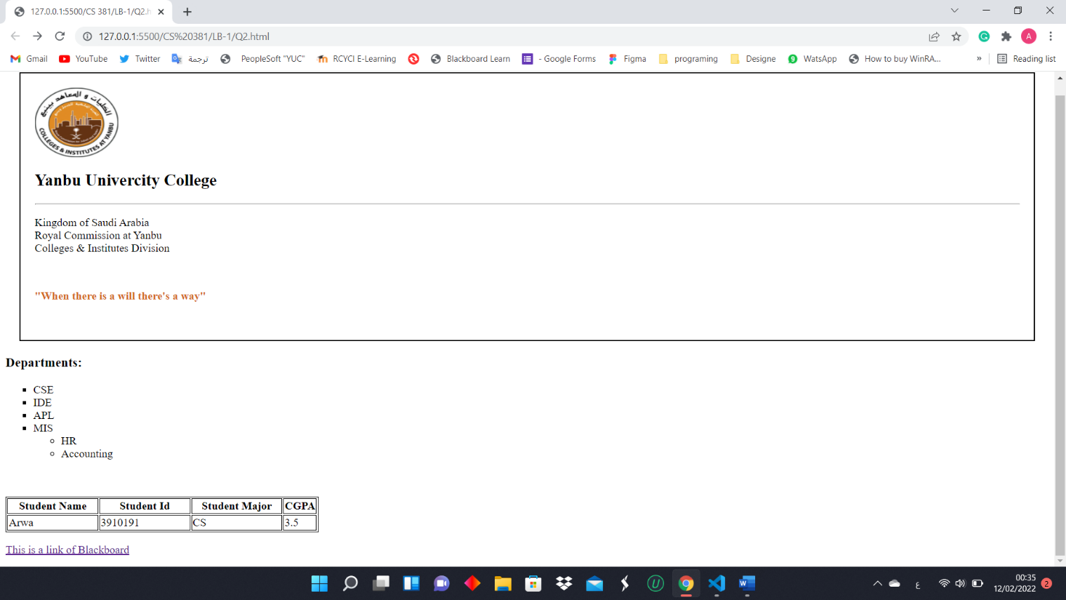Create a well-structured HTML page using as many semantic elements as you can.

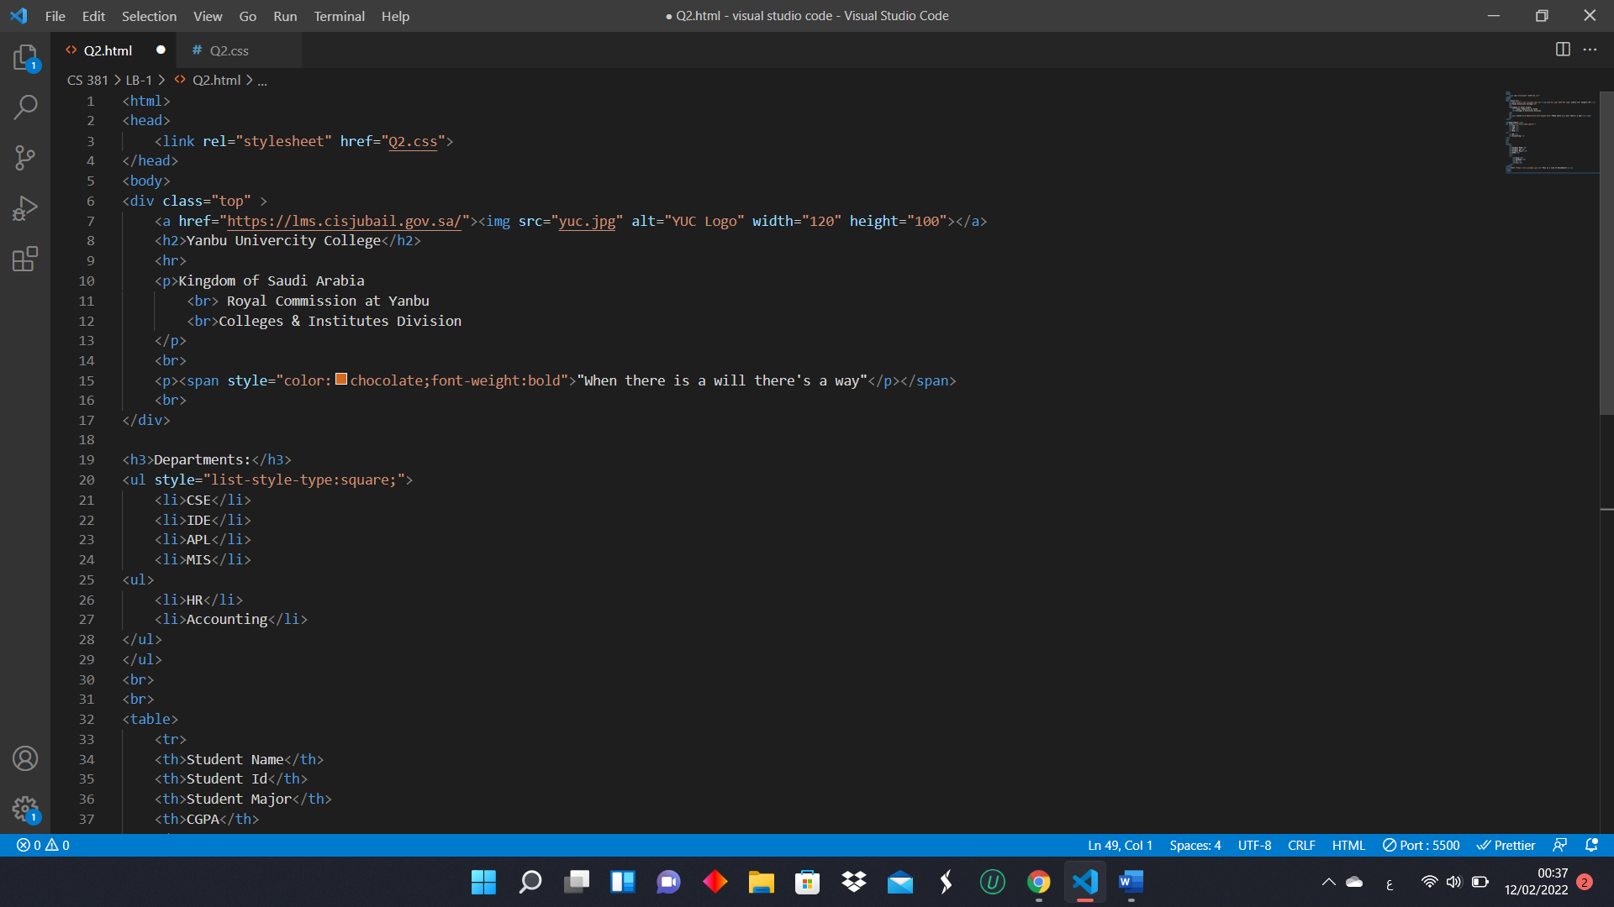**html code**

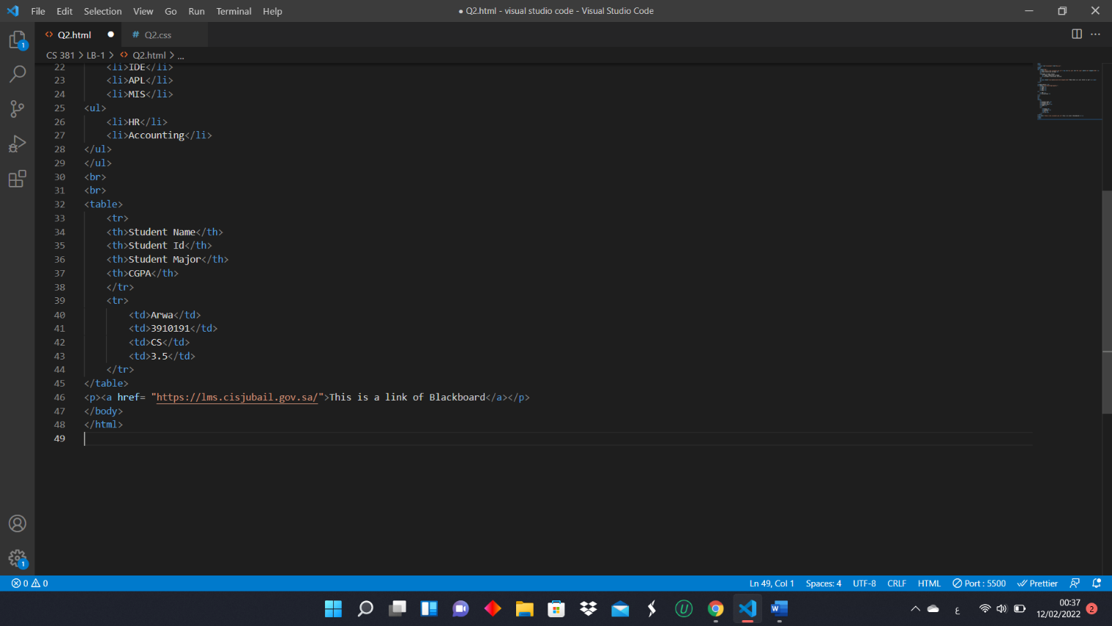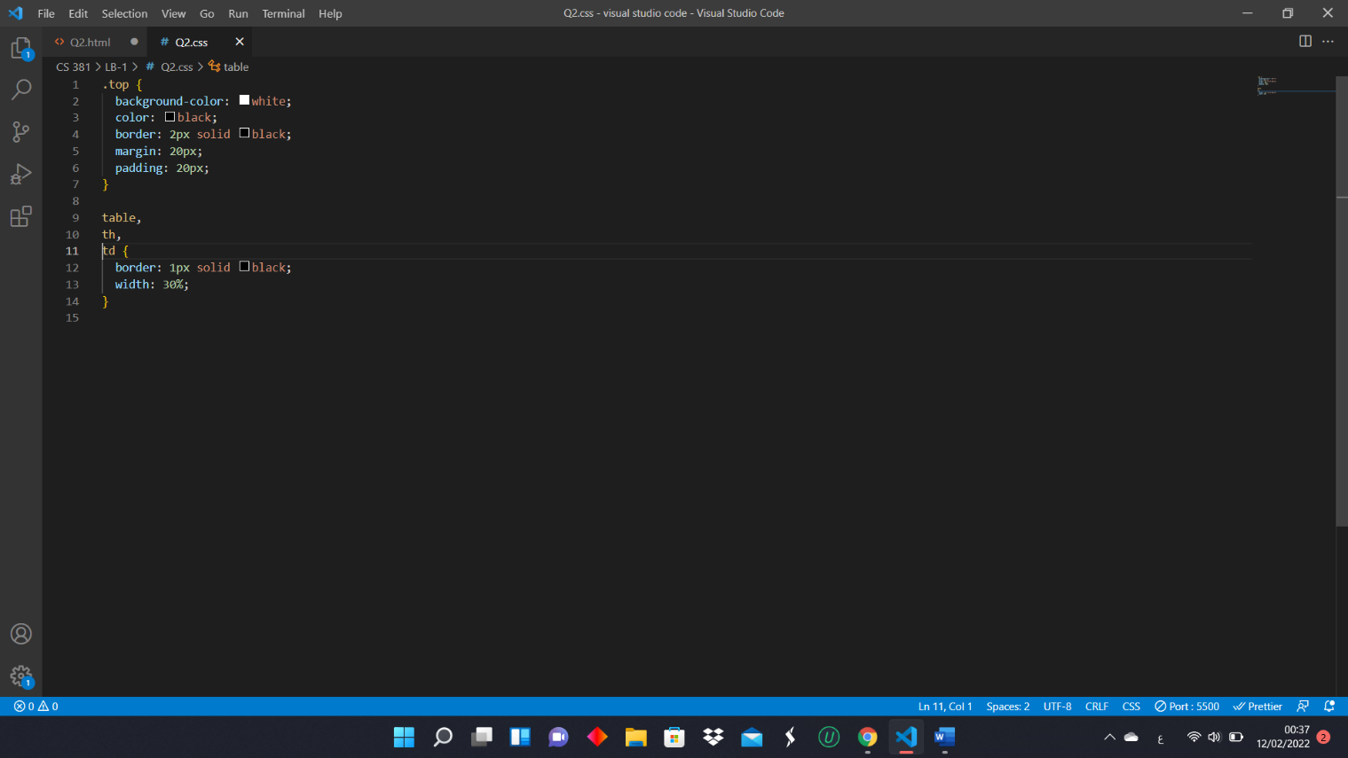**CSS code**